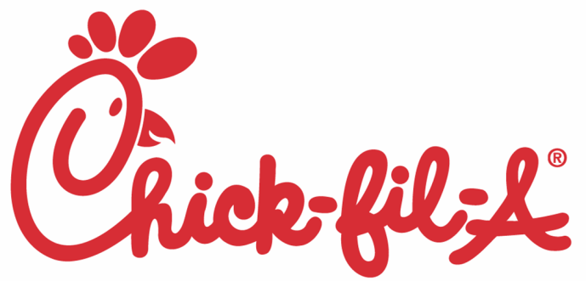It’s Day

# On Monday, September 18th

1--Please fill out and return the BOTTOM of this flyer with **EXACT CASH.**

2--Place this order and your cash in an envelope from home or a Ziploc bag.

3--All orders must land in the Chick-Fil-A box before **3:30pm, Wed, Sept. 13th!**

No late orders accepted. No refunds or credits for sudden absences.

**NO CHECKS PLEASE!** Exact Cash only, please!

**Yummy choices:**

**A------------------------------------ Crispy chicken sandwich $3.95**

**B------------------------------------------------- 8 piece Nuggets $3.95**

**C---------------------------------------------------------- Side salad $3.50**

**D—Grilled Market Salad, Spicy Southwest Salad or**

**Cobb salad (specify which salad plus dressing below) $9.00**

**E---------------------------------------------------------------- Chips $ .50**

**F------------------------------------------------------------ Juice box $ .50**

***Please Note: chips are potato chips: NOT waffle fries***

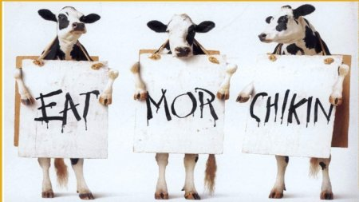

**--------------------------------------------------------------------------------------------------------**

**Please fill out and return BOTTOM portion only. Return with EXACT cash only.**

**FAMILY LAST NAME (Required)**

**Name Grade Meal Choices Total Price**

**Example: Emily 5 A, E, F 4.95**

**Total Due:**

**This order must land in the box by 3:30pm, Wed. Sept. 13th for your meal on Sept. 18th! Thanks!**