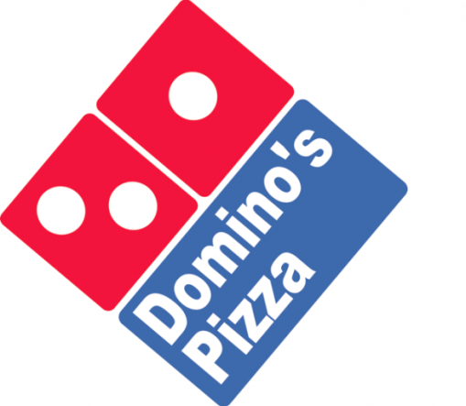
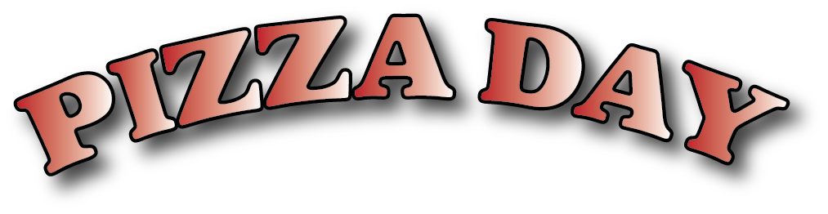
IS COMING!

MONDAY, February 26th!!

Please fill out, detach, and return the BOTTOM PORTION of this flyer with EXACT CASH. Place this order and your cash in an envelope or Ziploc bag from home so the money doesn’t get lost.

All orders must be placed in the PIZZA shoebox by 3:30pm on WEDNESDAY, February 21st!

No late orders will be accepted. Also, no refunds or credits can be given for sudden absences.
NO CHECKS ACCEPTED! Exact Cash only, please!
***Please try to limit use of coins***

The pizza will be cheese only, served in slices from Dominos.
Ranch dressing will be provided for the carrots. Juice boxes will be the drink.

MEAL A 1 Slice cheese pizza $ 1.50
MEAL B 1 Slice, carrots, drink $ 2.50
MEAL C 2 Slices pizza $ 2.75
MEAL D 2 Slices, carrots, drink $ 3.75
MEAL E 1 Slice, drink $ 2.00
MEAL F 2 Slices, drink $ 3.25

*Please note that the options for ordering whole pizza are no longer available in order to simplify serving the students.
---------------------------------------------------------------------------------------------------------------------

Please fill out, detach, and return BOTTOM portion only. Return with EXACT cash only

FAMILY’S LAST NAME:
Name GradeMeal Price
Example: Emily 5 A 1.50

Total Due:
This order must be placed by 3:30pm, Wed., February 21st for pizza on Mon., February 26th! Thank you!

